**InvestEU SME Window**

**Policy Note**

Table of Contents

Introduction 2

1. Access to finance for SMEs 2

2. Overview of existing central EU financial instruments for SMEs 6

3. InvestEU SME window 8

3.1 Debt financing 9

3.2 Equity financing 12

3.3 SME window contribution to EU policy priorities 13

3.3.1 Support for highly innovative SMEs 13

3.3.2 Supporting sustainable finance and contribution to the European Green Deal 14

3.3.3 Achieving digital transformation of SMEs 14

3.3.4 Supporting start-ups 15

3.3.5 Ensuring adequate finance for scale ups 15

3.3.6 Gender smart financing 16

3.3.7 Helping the Initial Public Offering (IPO) for SMEs 17

3.3.8 Supporting SMEs in the Cultural and Creative Sectors 17

# Introduction

This policy notes describes policy objectives and rational for the financial products to be supported by the SME window of InvestEU.

*[This policy note is still work in progress. It will be updated to align with further policy developments in the context of final decisions under the MFF and the new Commission.]*

# Access to finance for SMEs

Small and medium-sized enterprises (SMEs) are the engine of the European economy. SMEs represent 99% of the EU companies, employ 2/3 of the workforce and contribute to over 50% of the EU value added. Micro-enterprises make up the biggest share and account for 93% of all SME[1]s.

Innovative SMEs hold solutions to today’s challenges like climate change while the more traditional ones ensure socio-economic cohesion. Enabling SMEs to be competitive and exploit fully their growth and innovation potential is crucial for the EU prosperity.

However, obtaining financing in the form of debt or equity is a hurdle for SMEs’ creation and growth. In Europe, SMEs are heavily reliant on bank-based finance, which in 2018 accounted for roughly 90% of their financing needs while in the United States over a quarter of all financing was provided through capital markets.

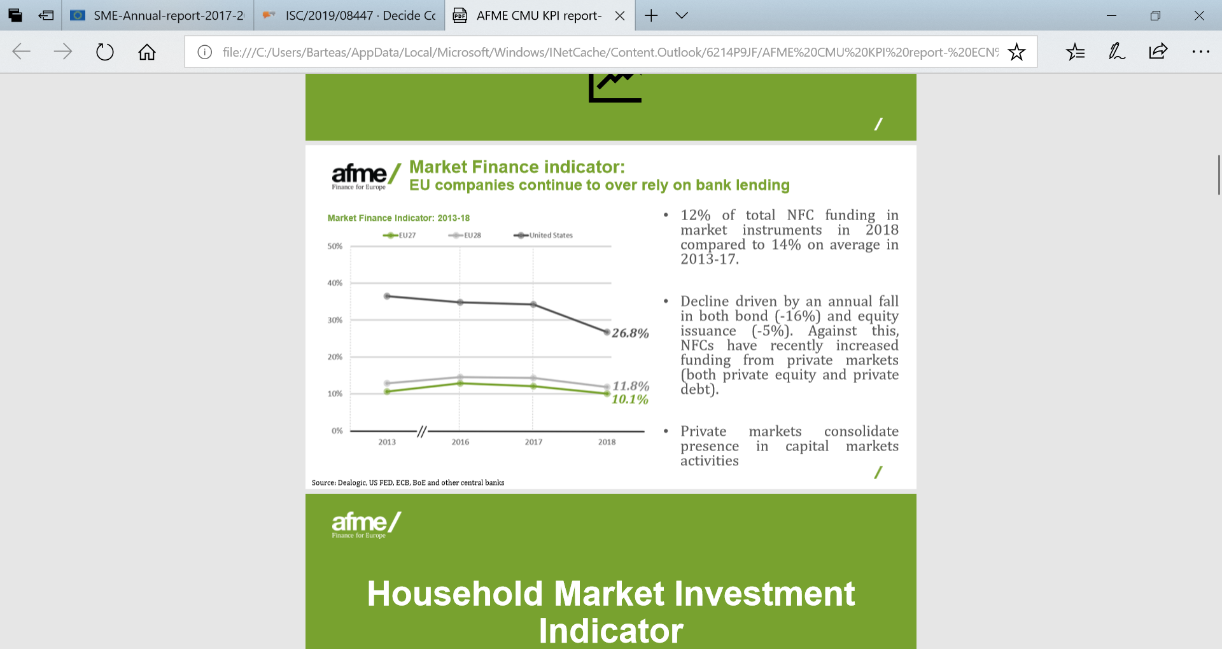

Source: afme, Capital Markets Union – Key Performance Indicators, edition 2019[2]

Furthermore, SMEs rely heavily on external sources of debt finance, in the form of credit lines, bank loans or leasing, to finance themselves, as **internal sources appear to be insufficient to meet their funding needs**.

As shown by the graph below, in 2018 SMEs reported that the three most important sources of financing for them were credit lines (relevant for 52% of SMEs), leasing (47%) and bank loans (47%). Equity financing was relevant for 12% of the EU SMEs, but only 2% actually used it.

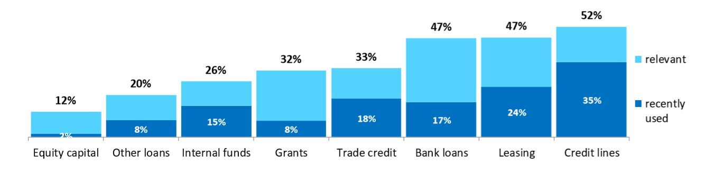

Source : 2018 SAFE survey

This relatively low ‘usage’ of equity finance is confirmed by recent afme data2, which shows that there is a steady increase in annual risk capital investments into SMEs, albeit starting from a very low level. The below data shows investment from venture capital, private equity (growth), business angel and equity crowdfunding as a % of risk capital and bank lending.

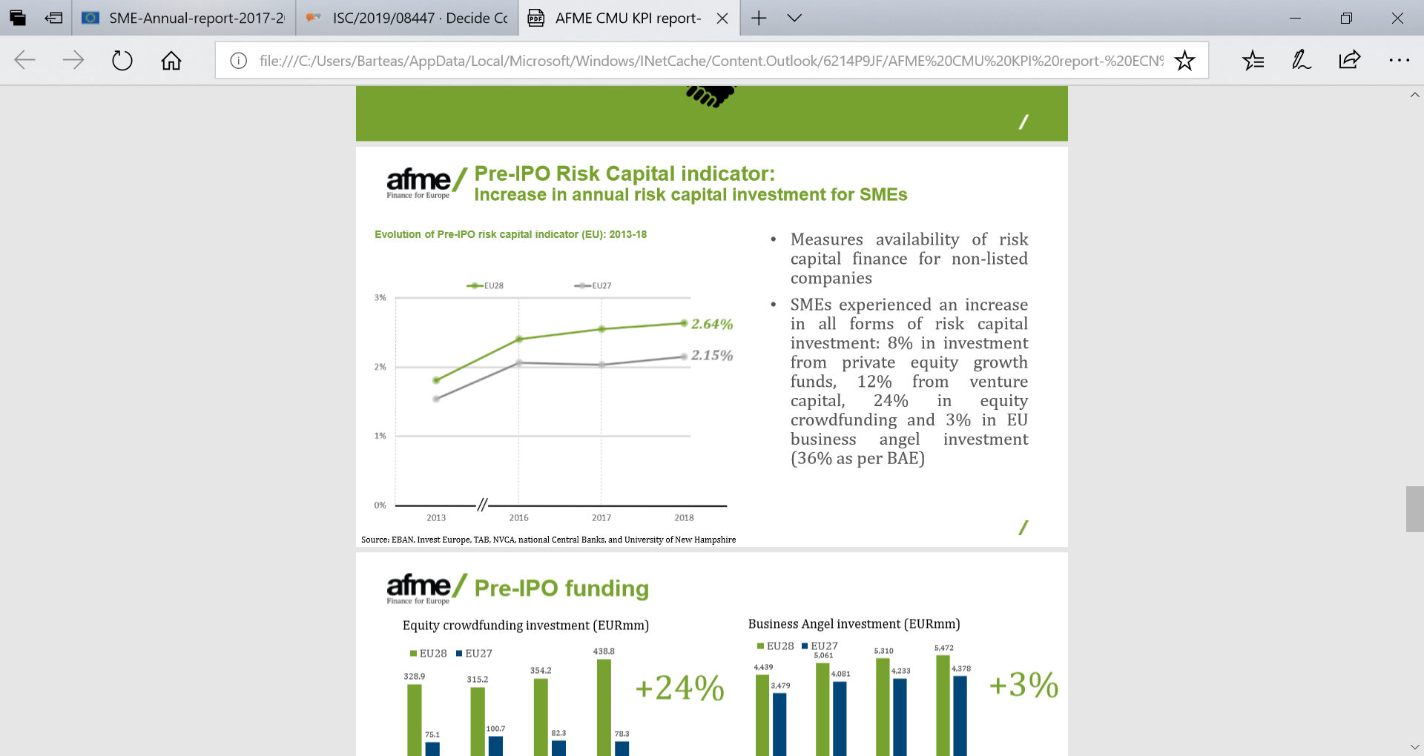

Source : afme, Capital Markets Union – Key Performance Indicators, edition 2019

More detailed data also shows, that the largest source of equity finance is provided through venture capital, followed by private equity growth capital and business angels. Equity crowdfunding plays a rather negligible role.

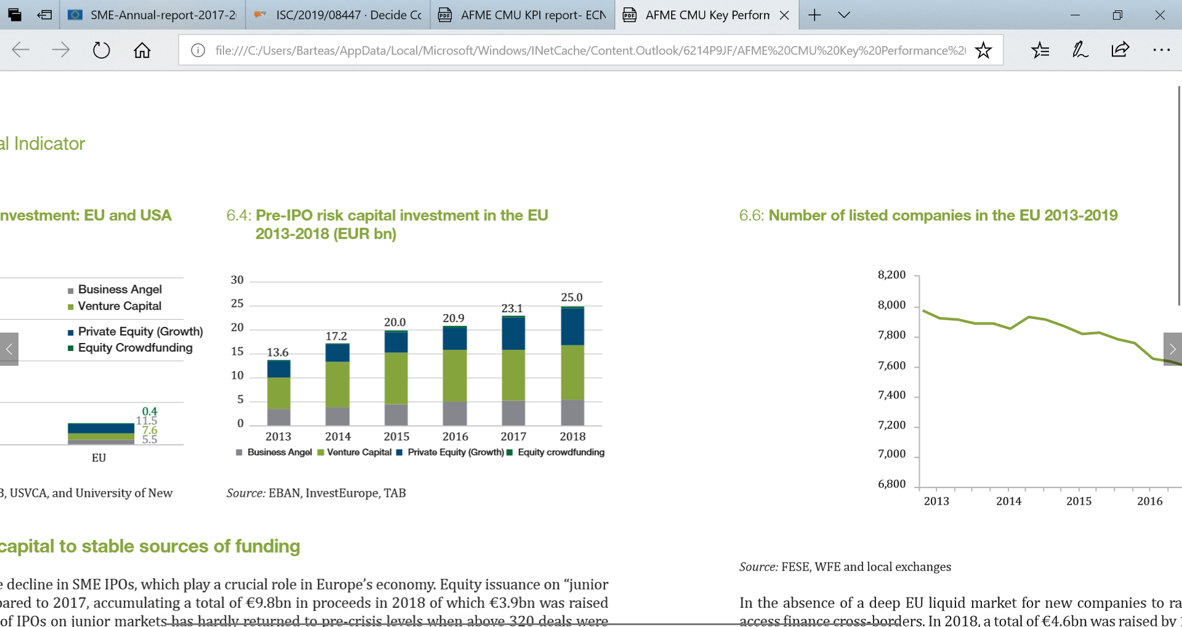

Source : afme, Capital Markets Union – Key Performance Indicators, edition 2019

When asking SMEs about their most important issues, the relevant importance of access to finance has decreased significantly as evidenced by the latest results of the SAFE survey:

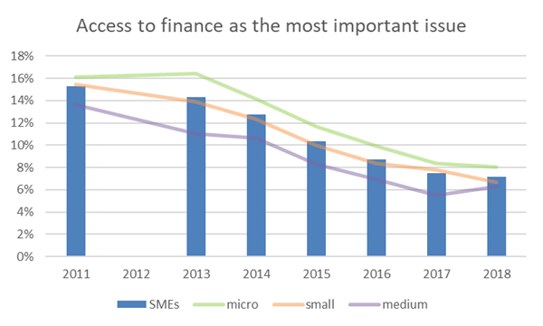

Source: SAFE survey 2011-2018

However, this positive average trend hides significant disparities among Member States:

*Access to finance as the most important issue for SMEs in 2018, in different countries:*

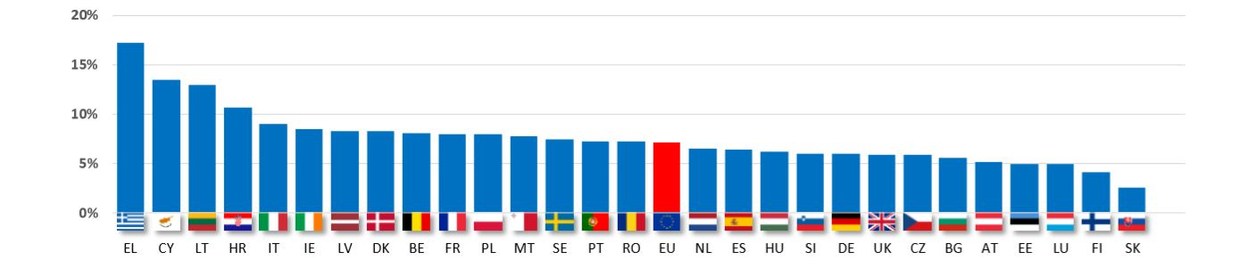

Source : 2018 SAFE survey

Furthermore, it has to be emphasised that substantial efforts have been underway at regional, national and EU level to provide access to finance support for SMEs through a variety of different programmes. Analysis conducted as part of the Commission’s Impact Assessment for the Single Market Programme[3] estimates that throughout the programming period 2014 – 2020 about **€ 113 billion p.a. of SME financing is supported through public interventions**. The amount can be further broken down into an estimated € 90 billion support through national programmes, about € 10 billion through European Structural and Investment Funds (ESIF) and about € 13 billion through central EU guarantees.

Without such combined efforts at regional, national and EU-level it can be assumed that the access to finance problem would have been a lot more pronounced.

In fact, when comparing the overall size of the new SME financing market per annum which tends to be supported through public support programmes (i.e. financing with maturities exceeding 1 year to support investments), which was estimated to amount to € 350 billion in 2017 (see Graph below) to the amount of SME finance supported per annum through public support programmes (€ 113 billion as indicated above), it appears that about **a third of all new SME debt financing with a maturity of more than one year benefits from some form of public support programme**.

Please note that this does not represent the overall size of the SME financing market, as it does not take into consideration short-term overdraft facilities, which are also extensively used by SMEs as evidenced through the SAFE survey.

New bank lending to non-financial corporations (original maturity over 1 year)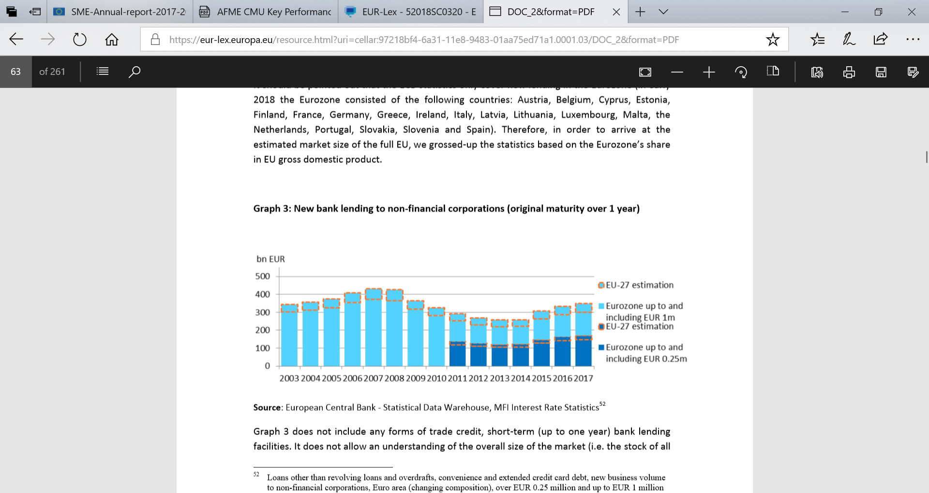

Source: Impact Assessment of the Single Market Programme[4]

The fact that about a third of medium to long-term SME financing is dependent on some form of a public support programme is also confirmed through a recent study undertaken by 5 National Promotional Institutes of France, Germany, Italy, Poland, Spain and the UK[5]. 34% of SMEs from those countries responded that they are currently using promotional funds as a source of financing.

Share of SMEs using promotional funds as a source of finance

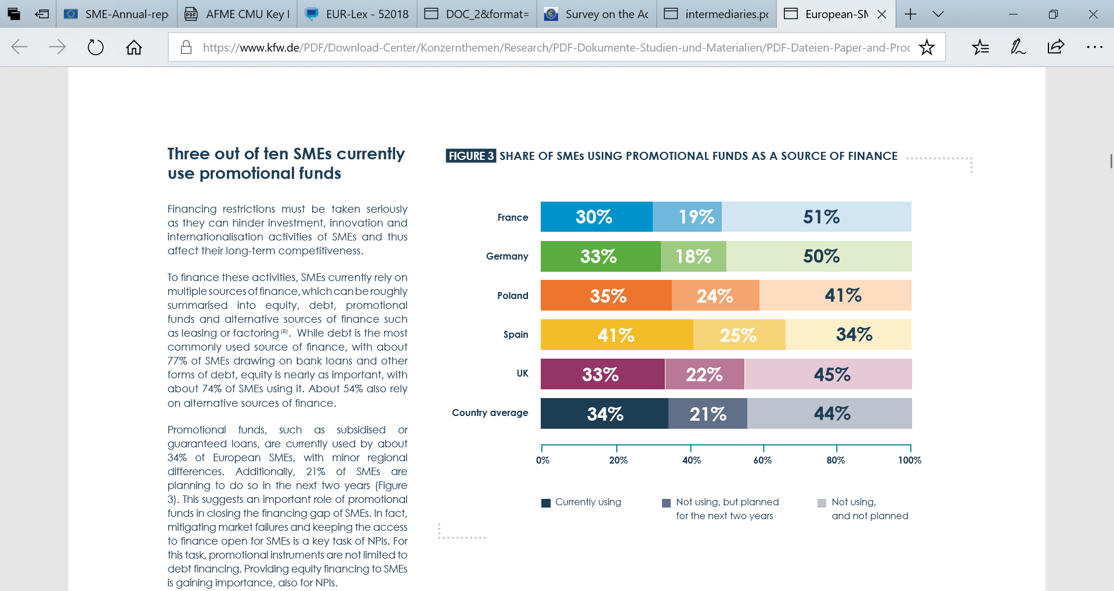

Such levels of public support in the SMEs finance area evidences the information asymmetry and fragility of SME financing market and persistency of the market gap, which is not tackled by the availability of the liquidity in the financial markets. Public support to SME access to finance plays and should continue playing an important role at reducing the existing market gap.

# Overview of existing central EU financial instruments for SMEs

Under the current Multiannual Financial Framework (MFF) there are a number of EU-level financial instruments targeting SMEs. Support to SMEs is also provided via the European Fund for Strategic Investments (EFSI) which has a window dedicated to SMEs. The numbers presented below represent the status as of 30/09/2019.

|  |  |  |  |  |
| --- | --- | --- | --- | --- |
| **Programme/product name** | **Debt/equity** | **Targeted final recipients** | **Product description** | **Allocated amounts** |
| **COSME** - Loan Guarantee Facility (LGF) | Debt | SMEs only | Loan guarantee facility to support SME financing transactions, specifically those with a perceived higher risk or those with insufficient collateral irrespective of sector or activity | 860.000.000 EUR  *EFSI enhancement*  *1.000.000.000 EUR* |
| **Horizon2020** - InnovFin SME Guarantee (SMEG) | Debt | SMEs and small mid-caps | Loan guarantee facility providing debt financing to research-based and innovative SMEs and Small Mid-caps established and operating in EU Member States and Horizon 2020 Associated Countries. | 999.000.000 EUR  *EFSI enhancement*  *1.100.000.000 EUR* |
| **Creative Europe** - Cultural and creative sectors (CCS) guarantee facility | Debt | SMEs and small mid-caps | Loan guarantee facility to support SMEs and organisations from the Cultural and Creative Sectors, coupled with the Capacity Building Scheme (technical assistance for financial intermediaries). | 121.000.000 EUR  *EFSI enhancement*  *130.000.000 EUR* |
| **EFSI -** ESIF-ESIF Combination product | Debt | SMEs only | The EFSI Combination Product is a financial instrument allowing for combinations of EFSI with Member State or Managing Authority resources coming from either (i) structural and investments funds (ii) national resources (iii) regional resources, or (iv) any combination thereof. The EFSI Combination product shall provide unfunded credit risk protection on a second loss basis. At a first stage, the EFSI Combination Product is rolled out only in the field of agriculture, for which EUR 150m of EFSI resources have been dedicated. | 300.000.000 EUR |
| **EFSI SMEW** - Private Credit for SMEs (Diversified Debt Funds - DDF) | Equity | SMEs and small mid-caps | To increase the volume and diversity of alternative debt financing available to European SMEs and Small Mid-Caps. The SMEW PC Product aims at contributing to the policy objective of a Capital Markets Union by: (i) increasing the availability of market-based and tailor-made funding solutions for European SME and Small Mid-Caps, (ii) encouraging pan-European investment activity beyond nationally focused investments, and (iii) facilitating a diversification of funding sources for SMEs and Small Mid-Caps. The Private Credit product shall provide equity investments in eligible diversified debt funds and, subject to market demand, provide protection through a risk sharing instrument to third party(ies) investment(s) in the same funds. | 300.000.000 EUR |
| **COSME** – Equity Facility for Growth (EFG) | Equity | SMEs only | Equity facility to invest in funds that invest into SMEs at the growth and expansion stage (funds investing cross-border or funds investing into SMEs that will internationalise). | 345.000.000 EUR |
| **Horizon2020** - InnovFin Equity (IFE) | Equity | SMEs and small mid-caps | InnovFin Equity (IFE) provides equity investments and co-investments to or alongside funds focusing on early stage financing of enterprises operating in innovative sectors covered by Horizon 2020, located or active in the EU or Horizon 2020 Associated Countries. The facility targets micro, SMEs and social enterprises promoting innovation. InnovFin Equity is available via four products: InnovFin Technology Transfer, InnovFin Business Angels, InnovFin Venture Capital and InnovFin Fund-of-Funds. | 344.200.000 EUR |
| **EFSI** – Expansion and Growth Window | Equity | SMEs and small mid-caps | The Expansion and Growth Window - to provide equity investments to or alongside funds or other entities focusing directly or indirectly on later stage and multi-stage financing of SMEs and small mid-caps.  The Early Stage Window - to provides equity investments and co-investments to or alongside funds focusing on early stage financing of – SMEs and small mid-caps operating in innovative sectors covered by Horizon 2020. | 2.320.000.000 EUR |

Source: DG ECFIN, GROW, RTD

Due to their high uptake and substantial amounts allocated, the instruments are contributing but are not *per se* sufficient to close the market gap, and – as evident from above – for many SMEs the access to finance still remains an important concern that needs to be addressed, including at EU level. It is envisaged that under the new MFF successor products to the existing instruments, albeit in a more streamlined format, will be established under the SME window of InvestEU.

# InvestEU SME window

Support under SME window will contribute to the Commission’s SME Strategy, which is aiming to help all types of EU SMEs - innovative, startups, scale-ups and traditional ones – to be competitive and exploit their growth and innovation potential.

The support shall be complementary to and underpin initiatives undertaken in the context of the Capital Markets Union. More specifically, financial products to be set up under the SME window of InvestEU shall not only provide support for more traditional bank finance, but shall also seek to diversify financing sources towards market-based instruments in order to reduce the overreliance of SMEs on the banking sector.

In line with Article 7(1) of the InvestEU Regulation, support under the SME window will seek to **facilitate access and availability of finance** primarily for SMEs as well as small midcaps, at any stage of their development, and enhance their sustainability and global competitiveness. It will focus in particular on those SMEs and small midcaps that are perceived high risk and lack sufficient collateral, especially in their early development stages.

Support shall be provided in the form of debt financing, including subordinated debt, equity and quasi-equity financing, in order to increase the ability of SMEs and small mid-caps to finance their creation, growth, development, and transfer, withstand economic downturns, and for making the economy and the financial system more resilient during economic downturn or shocks. Support shall be provided for investment and working capital as well as for risk financing from seed to expansion stages to ensure technological leadership in innovative and sustainable sectors, in particular by targeting SMEs whose activities focus on intangible assets because of research, innovation and digitalisation activities or because of sector specificities such as cultural and creative sector. When necessary it may provide financing for the acquisition of a business or a participation in a business by employees.

## Debt financing

Following the financial crisis in 2008, new bank lending contracted considerably and the SME securitisation market in Europe collapsed. New regulatory requirements, leading to higher capital requirements (e.g. Capital Requirements Regulation (CRR) and Capital Requirements Directive (CRD)) and the need for banks’ deleveraging, negatively impacted banks’ willingness and ability to lend and to accept risk.

This had a major negative effect on available SME bank finance across the EU. Credit standards tightened considerably, particularly for SMEs, which, as a consequence, experienced a credit crunch. Credit standards only started to ease after 2013 when SMEs also started to have a more positive perception of the availability of bank loans.

*Changes in credit standards and availability of loans*

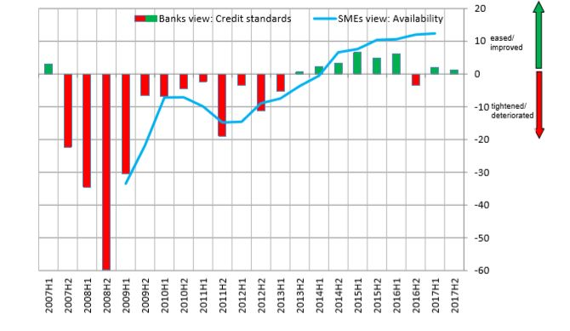

Source: ECB Bank Lending Survey; SAFE survey

Since late 2014 there is an increase in new lending to corporations in line with economic growth in the Eurozone and the positive impact of policy/regulatory instruments, such as the introduction of the SME supporting factor in 2014 or the start of quantitative easing by the ECB in March 2015[6]. All of these activities have led to an improvement in the availability of bank finance, and the conditions for access to finance have on average recovered. However, as regards volume of lending, pre-crisis levels have not been reached yet. The recent impact assessment[7] accompanying the Single Market Programme proposal demonstrates that the debt financing gap at EU level showed a substantial peaking at €42 billion in 2014, which has subsequently seen a reduction to less than €30 billion in 2017.

The 2018 OECD scoreboard on Financing SMEs and Entrepreneurs notes that "new lending to SMEs depicts a more negative picture than in previous years". Growth in new SME loans in 2016 was negative in 15 out of 25 countries covered by the OECD scoreboard. The decline in new lending can be attributed to several factors, often depending on national circumstances. In some countries this can be attributed to lower demand linked to weak investment dynamics. In other countries, such as Greece, Slovenia and Portugal, financial institutions appeared to have become more risk-averse when lending to SMEs.

Moreover, financial markets in the Member States show different degrees of development, in terms of the number of players present in the market, the diversity of financial institutions present, product offerings and risk appetite. SMEs have no means of overcoming these national differences because they rely on local/national providers of finance. SME financing is predominantly provided within national boundaries due to regulatory constraints, investor home bias and the regional focus of many SMEs. Cross-border lending is only at a nascent stage, predominantly fuelled by the emergence of Fintech companies.

The financing problem is acute for firms that are undertaking activities with significant financial, technological, organisational or business-model risk and those wanting to finance growth projects that do not result in the acquisition of fixed assets that could be collateralised (e.g. in the area of culture and creativity, digitisation, internationalisation, etc.).

Furthermore, undertaking innovative and other high-risk activities, which are poorly understood by finance providers, results in low credit scores and leads to high interest charges to compensate for the perceived risk, provided that a finance provider is willing to offer the finance at all, rather than reject the application outright.

Younger and smaller companies or those requiring rather small financing amounts are faced with a structural financing gap due to information asymmetries, lack of financial track records and disproportionate file costs.

Younger companies, i.e. companies in their first five years of existence, are perceived to be very risky by lenders because they have no financial track record and statistics indicate that less than 50% of businesses survive during the first five years of their establishment. The SAFE survey results confirm that younger companies consider access to finance to be more problematic than more established SMEs.

*SMEs reporting access to finance as the most important problem: younger and older EU-27 SMEs*

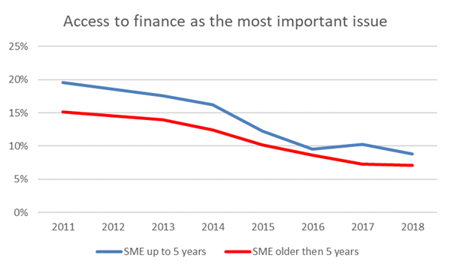

Source: SAFE survey 2011-2018

In view of the above, the SME window will support the provision of debt financing primarily to SMEs (as well as small midcaps) for higher risk portfolios in the following instances:

* Financing transactions which are currently not provided to start-ups (or provided to certain categories of start-ups, or to previously excluded start-ups);
* Financing transactions which are provided with existing features but cover previously excluded categories of recipients where such categories of recipients are excluded for credit risk reasons);
* Financing transactions which are provided with new features (such as increased maturities and/or reduced collateral requirements);
* Financing transactions on a subordinated basis which have previously not been offered due to their higher credit risk;
* Bespoke financing transactions provided by debt funds, including on a cross-border basis, to enhance the availability of market-based financing in line with the objectives of the Capital Markets Union.

It will seek to support enterprises operating in clearly defined underserved economic sectors and enterprises undertaking clearly identified structural changes, thus contributing to the achievement of EU policy priorities.

Support will build on the COSME LGF experience, whereby it has been demonstrated that the capped approach vis-à-vis the implementing entity, which provides for a significantly higher leverage, has been sufficient to entice financial intermediaries to apply and to encourage them to create higher-risk debt financing products.

In order to achieve additionality, support should lead to the financial intermediary/implementing partner broadening its business activity by establishing a new portfolio of financing transactions, which it would not have financed in the absence of the EU guarantee. It should also be additional to any private or public schemes that are existing in the same area.

## Equity financing

Innovative SMEs, including start-ups and scale-ups, are often facing difficulties in obtaining financing, particularly equity, at the stages of creation (starting-up) and further development and growth (scaling-up). In credit markets, adverse selection and moral hazard are exacerbated in the case of young, innovative businesses without loan history or collateral to secure a loan. Innovative firms are more financially constrained due to asymmetric information, lack of collateral and sunk cost. Due to their higher risk profile, fast-growing companies typically suffer from higher loan rejection rates.[8] The impact assessment of the 9th Framework Programme for Research and Innovation points to limited scale-up of innovative SMEs at EU level and lack of venture capital as major issue.[9] Taking measures to facilitate equity investments and making existing public measures simpler may prove crucial for facilitating financing in the future.

In line with the Capital Markets Union objectives[10], stronger capital markets in Europe and the development of equity financing could overcome some funding constraints stemming from the companies' overreliance on debt finance and address the issue of over-indebtedness of parts of the EU corporate sector. Moreover, stronger European capital markets would provide for a better risk transfer and risk sharing across Member States. As such, a favourable development in equity markets would play a key role in providing the necessary boost to the current cyclical upturn of the European economy.

As indicated in the beginning of this policy note, equity is an under-used finance mechanism: only 12% of SMEs currently consider equity financing relevant for their business and only 2% of SMEs use it. However, for high-risk start-ups and high-growth companies that require significant long-term investments and which do not produce immediate free cash flows, equity investment is an important financing component.

Also as indicated in this note earlier, equity finance is provided mainly through business angels (for the early-stages), venture capital fund and through private equity growth funds.

But despite the overall steady increase in nominal amounts of equity finance in the EU, equity finance made available to SMEs in the US in 2018 is about 8 times higher than equity finance available in the EU.

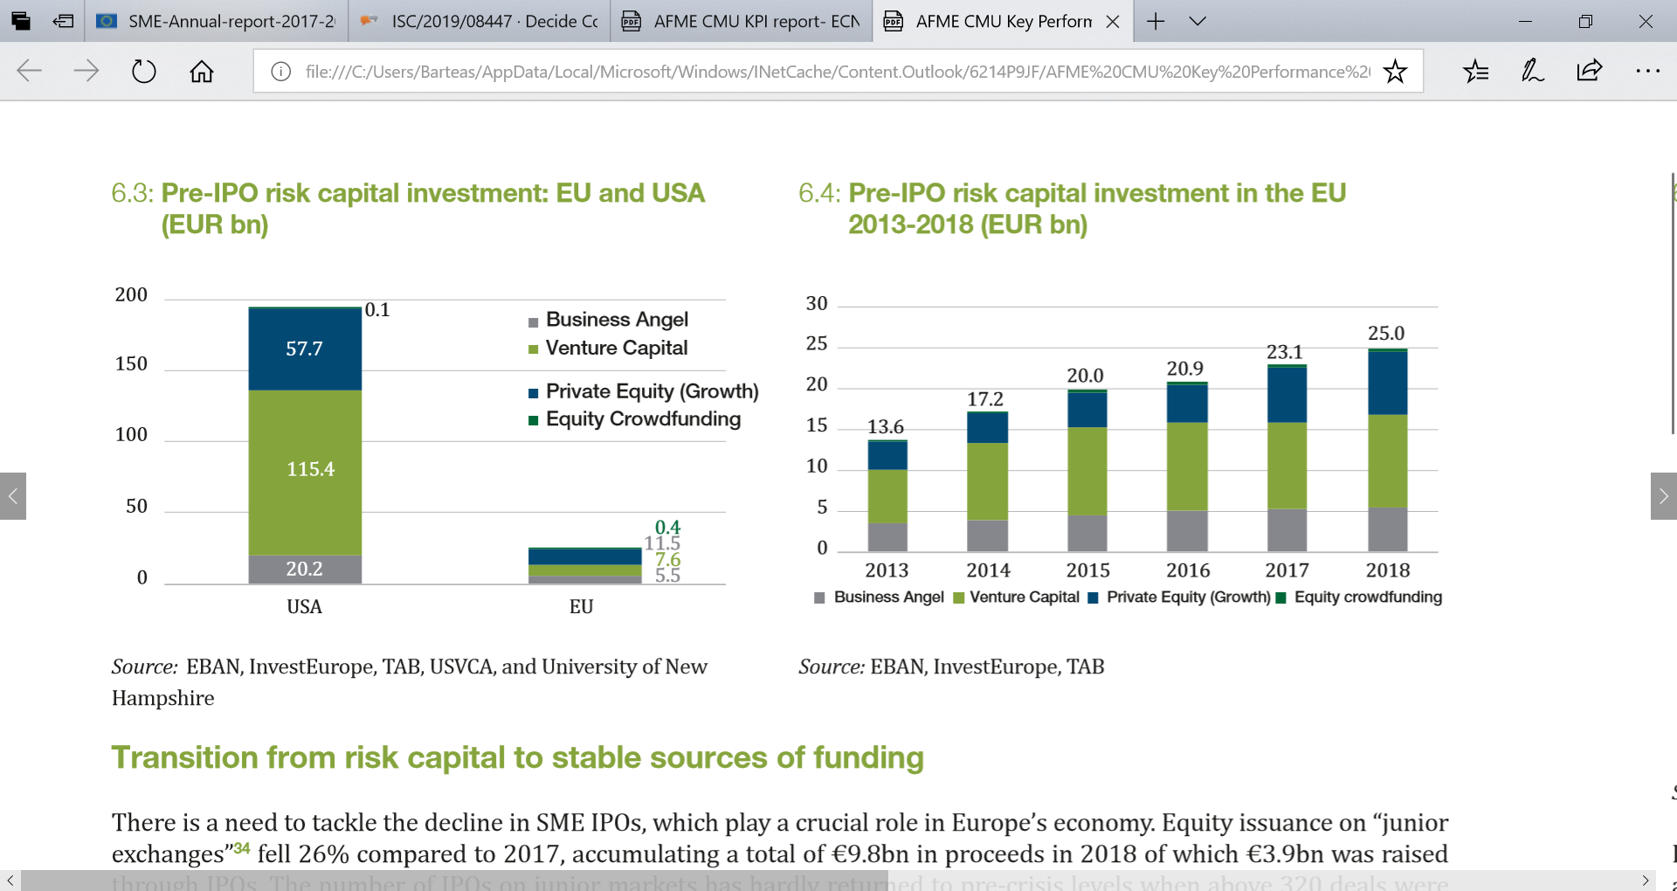

Source : afme, Capital Markets Union – Key Performance Indicators, edition 2019

Yet, a lot of investors consider the risk/return profile for venture and growth capital investments inappropriate and the cost of undertaking research too high. Moreover, investors find it inefficient to invest because funds in Europe are often too small. These framework conditions create a market gap for equity risk capital finance, which needs to be further documented, analysed, and addressed.

The equity product under the SME window will therefore aim to broaden the range of financing options for companies with strong growth potential, by providing equity and quasi-equity to SMEs and small midcaps from the early to growth stage of their development.

## SME window contribution to EU policy priorities

All sectors listed in Annex II of the InvestEU Regulation are in principle eligible for support. However, products to be created under the SME window may provide more specific support for certain areas of higher policy value.

## Support for highly innovative SMEs

The globalisation, the high degree of interconnectivity and new technological advances have forced many SMEs to reinvent not only their products and services, but also their business and organisational models, in view of staying competitive in a fast-paced economy.

But innovative European SMEs, including in their start-up and growth phase, face a real problem to attract suitable financing solutions. Adequate access to finance is widely considered a key precondition to ensure further growth and development of these companies. One of the major weaknesses of Europe with regard to innovative SMEs lies on the lack of focus on developing intellectual property (’IP’) portfolio strategies to protect their R&D investments and make them more attractive to investors, raise growth capital and remain competitive in Europe and globally[11].

While financing through equity is often regarded as the appropriate source of funding for highly innovative firms, the limited size of the European venture capital industry and the ‘bank culture’ predominant in the Member States leads to the fact that many highly innovative firms rely on ‘classic’ debt financing. Furthermore, innovative and other high-risk activities, which are poorly understood by finance providers, results in low credit scores and leads to high interest charges to compensate for the perceived risk, provided that a finance provider is willing to offer the finance at all, rather than reject the application outright.

## Supporting sustainable finance and contribution to the European Green Deal

To achieve the EU's 2030 targets agreed in Paris, including a 40% cut in greenhouse gas emissions, the EU has to fill an investment gap estimated at 180 billion EUR per year. In the coming years, the EU has to massively support investments for the development and deployment of technologies promoting climate neutrality. In the context of limited availability of public resources, the engagement of the private sector and the efficient solutions for financing sustainable growth are indispensable.

Recent Commission’s regulatory proposals represent important steps towards more competitive, climate neutral EU economy. More precisely, actions under the EU Action Plan on Financing Sustainable Growth will enable concrete progress in harnessing financial markets to support the objectives of EU sustainable growth agenda and to contribute to the Agenda 2030 for sustainable development and its sustainable development goals (SDGs).

Europe’s entrepreneurs, and particularly the smaller enterprises, are amongst the key drivers of sustainable business practices. At the same time, however, start-ups, micro-enterprises and SMEs in general tend to experience more difficulties in adopting sustainable strategies and practices, due to their more limited organisational, technological and financial capacity; and less access to (pre-) financing for circular solutions, and are in greater need for financial support in order to ensure their transition to sustainability.

## Achieving digital transformation of SMEs

Disruptive digital technologies, such as the Internet of Things, cloud computing, high-performance computing, 3D printing, blockchain and AI are transforming business models and provide unprecedented opportunities for fostering competitiveness and economic growth in Europe. Innovations in digital technologies are fundamentally changing the way companies produce, commercialize goods and services, as well as interact with customers.

The adoption of these digital technologies by European SMEs across all sectors is essential for Europe to remain competitive in a global marketplace. However, the digitalisation of companies in Europe varies significantly by geography, sector and type and size of company - while 54% of large companies are highly digitalised, only 17% of SMEs have successfully integrated digital technologies into their businesses. A breakdown by sector shows that the most digitalised sectors include the telecommunications (59%) and publishing sectors (54%), while the food manufacturing (13%) and basic metal manufacturing (9%) sectors stand as the least digitalised in Europe. Digital late-adopters include asset-heavy sectors such as basic good manufacturing and mining, quasi-public sectors such as health care and education, and highly localised and fragmented industries such as agri-food and construction.

Supporting the adoption of digital technologies by SMEs is imperative in order to improve their competitiveness, prepare SMEs to expand into new markets and/or adjust to structural changes. While there are several factors that lead to a low digitalisation rate (including the willingness of traditional SMEs to adapt due to their insufficient knowledge- and skill-base), the limited access to finance is one of the elements that negatively affects the possibility for traditional SMEs to digitalise.

## Supporting start-ups

Startups are a critical element for the economic vitality, they are the pipeline for SMEs and future high-growth ﬁrms. Across Europe, startups contribute to make countries economically and socially vibrant by redeﬁning the technological landscape and creating the markets of tomorrow. One of the signiﬁcant economic contributions made by startups is job creation. The average number of current employees varies according to the stage of development of the startup – from 3.5 average number of employees in the pre-seed/seed stage, to 15.1 in the growth stage[12].

However, lack of access to finance is a common barrier for most new enterprises, reflecting in large part the lack of collateral assets and own financial resources as companies in the preseed/seed and startup stage are often not yet proﬁtable. While internationalisation is a goal for many startups, there are many obstacles, which they need to overcome to make internationalisation possible, with “ﬁnding the right partners”, “lack of ﬁnancial support” and “legislative/regulatory barriers” being the most widely highlighted.

## Ensuring adequate finance for scale ups

Both academic evidence and public consultation confirm that for companies in the scaling-up phase there are substantial differences in the EU compared to the US – one of eight companies in the EU do scale-up, against one out of four in the US.

These differences are also reflected by substantial distinctions in VC fund and deal sizes - while at the start-up stage there is relatively little difference US vs Europe in terms of fund size, US companies are funded by significantly larger funds at the scale-up stage. Moreover, in the period 2007-2015, the average venture capital-backed US company received five times higher amounts than its EU counterpart (EUR 6.3m compared to EUR 1.3m).

European venture capital funds do therefore not have sufficient volume to help companies grow from start-ups to mid-caps and on to global players. There is 14 times more venture capital available for later stage in the US than in the EU. The average size of European VC fund in the EU is €61 million and 50% of all VC funds were smaller than €27 million. In contrast, the average US VC fund in 2014 was $135 million in size[13].

Hence, it is logical that companies that are looking for, say, €30m find it hard to find that money in Europe. This is a particular problem for scale-ups, as the supply of funds tends to dry up as they move to later stages of financing. Securing finance for expansion was listed by 65% of respondents as the number one obstacle to scaling up within the EU. A recent study carried out by InnovFin Advisory[14] shows that over 90% of smaller European companies active in advanced technologies struggle to raise the amounts of finance they need to scale-up.

Due to this scale-up gap, Europe is not reaping the benefits of the most promising young companies it has nurtured, once they pass the seed, start-up and early expansion stage and embark on an ambitious, global growth path for which they seek higher investment ticket sizes. In the process, Europe loses much needed entrepreneurship, technological know-how, and jobs. Thus on average 44% of the venture capital companies backed by EU investee funds which were sold were acquired by non-European buyers, in particular from the US. Finally, the equity gap is estimated at 1.25% of GDP in the US against 3% of GDP in the EU[15].

## Gender smart financing

Traditionally, women feature as beneficiaries of social investment, as accessing finance is more difficult for women entrepreneurs than it is for male entrepreneurs. This stems from a range of factors, as women entrepreneurs are different from men, but also from gender bias on the investors side. The focus on diversity and motivations of the providers of finance, the supply side, is increasing. In 2002, a literature review concluded there was no single study looking at experience of women in accessing equity investment. Nowadays social media and press, in particular in the US, feature many female founders and investors denouncing the lack of diversity in investors’ community and launching their own ventures to question the status quo. Women are no longer simply the beneficiaries of social finance, but the driver for building a complete ecosystem of social investing that has female financial power at its heart.

Diverse teams exhibit strong returns and outperform market benchmarks. Greater gender diversity is correlated with higher profitability, innovation and value creation. It has also significant macroeconomics effects in terms of GDP growth and higher productivity. In venture capital, women-led companies require less capital while delivering higher returns[16].

Nevertheless, women businesses are often under-capitalised and use less external financing, instead relying on personal savings and spousal funds (OECD, 2018). They attract fewer early stage equity investments, both in the form of venture capital and angel investment. According to the State of European Tech 2018 Report by Atomico, in Europe all-male founding teams receive 93% of the capital invested and account for 85% of deals. 5% of capital goes to mixed teams and only 2% to all-female teams.

## Helping the Initial Public Offering (IPO) for SMEs

Enhancing the financing of companies, especially the small and medium-sized enterprises (SMEs), has been at the core of the Capital Markets Union since its inception in 2015. Several changes have been made to the regulatory framework to facilitate SMEs access to capital markets, in particular to facilitate their listing on public markets. The Commission also proposed new rules to reduce administrative burden and compliance costs for SMEs seeking a listing on SME Growth Markets.

Yet the still difficult access of SMEs to non-banking financing sources highlight the need to do more to support scale up and access to public markets of SMEs. SMEs’ access to capital markets is still rather costly and hindered by barriers, notably related to the difficulty to attract enough investors leading to a low number of Initial Public Offerings, insufficient data on SMEs, limited visibility and comparability of SMEs towards institutional investors, low liquidity in SME equity, SMEs’ limited knowledge about equity finance and listing process, high initial costs of issuing equity, and heterogeneous governance codes across the EU.

SMEs access to public markets is crucial to enabling companies to scale up and diversify their funding mix. Newly listed SMEs are a key motor of new investments and job creation. Companies recently listed often outstrip their privately-owned counterparts in terms of annual growth and workforce increase. The benefits of listing include a reduced dependency on bank financing, a higher degree of diversification of investors, easier access to additional equity capital and debt finance (through secondary offers) and higher public profile and brand recognition.

## Supporting SMEs in the Cultural and Creative Sectors

The Cultural and Creative Sectors (CCS) span a wide range of activities, including audiovisual and broadcasting, print, music, visual and performing arts, heritage, design and architecture. With 6.7 million jobs, accounting for 4.5%[17] of the overall GDP, the CCS is the third largest source of employment[18] in the EU. The CCS is growing across Europe at above average rates, and is a significant source and user of innovation. Start-ups, SMEs, mid-caps and not-for-profit organisations play key roles in creating and maintaining cultural identities and diversity. However, the sector faces specific challenges in funding new activities and enabling growth; these constraints are linked to market failures at local, pan-European and global levels.

Market research has indicated that access to funding is one of the key barriers encountered by entrepreneurs, SMEs and other organisations working in CCS. The barrier is related to the intrinsic characteristics of CCS activities; the nature of CCS organisations and entrepreneurs, as well as the market conditions specific to the sector. These characteristics include: the intangible nature of many CCS assets (making them difficult to evaluate); lack of track record among companies; limited transferability of assets (which makes for poor collateral and reduces the appetite of venture capital investors); existence of information failures between finance providers and companies; difficulties in assessing business models; European financial intermediaries lacking the in-house expertise to evaluate risk associated with CCS opportunities; also, more widely, the range and fragmentation of activities across CCS, which affects external perceptions and understanding and limits economies of scale. Whilst some of these barriers may be faced by SMEs in other sectors, they tend to be more pronounced in CCS, especially for small companies. The result is a ‘finance gap’ for CCS enterprises: in 2013, a feasibility study for the EC which involved an online survey of CCS businesses, estimated the total financing gap to be between €8 and €13bn over the seven-year period from 2014 to 2020.

---------------------------------------------------

1. Annual report of European SMEs 2017/2018, p. 14: <https://blogs.ec.europa.eu/promotingenterprise/files/2018/11/SME-Annual-report-2017-2018.pdf>
2. afme, Capital Markets Union – Key Performance Indicators, edition 2019: <https://www.afme.eu/reports/publications/details/Capital-Markets-Union--Key-Performance-Indicators-Second-Edition>
3. <https://eur-lex.europa.eu/resource.html?uri=cellar:97218bf4-6a31-11e8-9483-01aa75ed71a1.0001.03/DOC_2&format=PDF>
4. <https://eur-lex.europa.eu/resource.html?uri=cellar:97218bf4-6a31-11e8-9483-01aa75ed71a1.0001.03/DOC_2&format=PDF> , p. 315
5. <https://www.kfw.de/PDF/Download-Center/Konzernthemen/Research/PDF-Dokumente-Studien-und-Materialien/PDF-Dateien-Paper-and-Proceedings-(EN)/European-SME-Survey-2019.pdf?kfwnl=Research.06-11-2019.553024>
6. https://www.ecb.europa.eu/mopo/implement/omt/html/index.en.html
7. Impact assessment accompanying the proposal for the Single Market Programme, part 2, p.312: <https://ec.europa.eu/commission/sites/beta-political/files/budget-may2018-single-market-swd2_en.pdf>
8. Enabling SMEs to scale up, OECD Discussion Paper, February 2018 https://www.oecd.org/cfe/smes/ministerial/documents/2018-SME-Ministerial-Conference-Plenary-Session-1.pdf
9. Very few European start-ups survive beyond the critical phase of 2-3 years, and even fewer grow into larger mermaids. Less than 5% of European SMEs grow internationally. Venture capital in the EU is one-fifth the level of the USA. See <https://ec.europa.eu/info/sites/info/files/swd_2018_307_f1_impact_assesment_en_v7_p1_977548.pdf>
10. Action Plan on Building a Capital Markets Union, https://eur-lex.europa.eu/legal-content/EN/TXT/PDF/?uri=CELEX:52015DC0468&from=EN
11. Horizon 2020 Work Programme 2018-2020.
12. European Startup Monitor, 2019
13. Figures EU report 2015 and NVCA report 2016.
14. Study on access-to-finance conditions for KETs companies carried out with the support of Roland Berger Strategy Consultants
15. Fl. Lopez de Silanes, et al, Estimating the financing gap, 2015
16. In a study from Boston Consulting Group, women outperformed their male counterparts despite raising less money. The study revealed that, for every dollar of investment raised, female-run startups generated 78 cents in revenue, whereas male-run startups generated only 31 cents. A survey of the nearly 600 founders found that those who were part of a team with a female founder performed 63% better than all-male counterparts.
17. Ex-ante evaluation of new financial instruments for SMEs, mid-caps and organisations from the Cultural and Creative Sectors (2019)
18. EC (2017) Report from the Commission to the European Parliament and the Council. Mid-term evaluation of the Creative Europe programme (2014-2020)