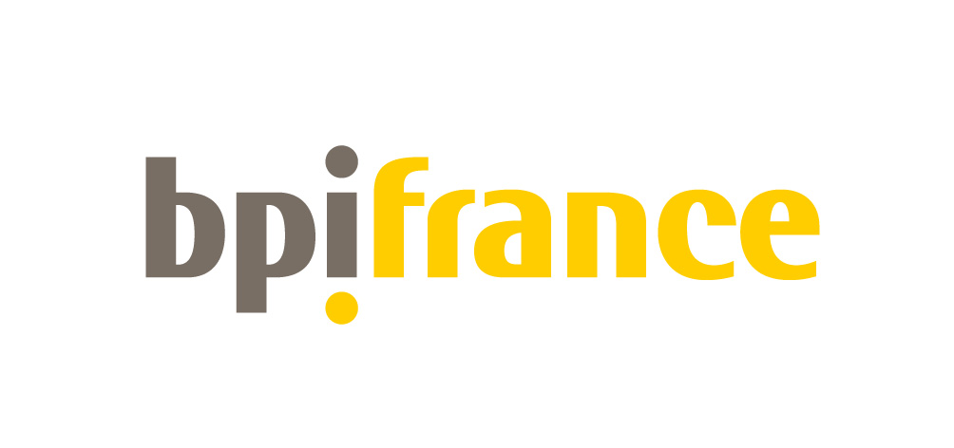
Bpifrance Networks INVITED
April 15th 2015

AECM : European Association of Mutual Guarantee Societies

AECM has 40 member organisations operating in 20 EU countries, Montenegro, Russia and Turkey. Its members are mutual, private sector guarantee schemes as well as public institutions, which are either guarantee funds or Development banks with a guarantee division. They all have in common the mission of providing loan guarantees for SME who have an economically sound project but cannot provide sufficient bankable collateral. In 2013, AECM member organisations had a total guarantee volume in portfolio of over 76 bn. EUR and issued a total volume of over 25 bn. EUR of new guarantees (provisional figures)
  - AECM website: http://www.aecm.eu/en/aecm-european-association-of-mutual-guarantee-societies.html?IDC=18&IDD=24

- People invited
- The President of AECM, José Fernando Figueiredo
- Katrin Sturm
- Siagi
- SOCAMA
- Sowalfin (Belgium)

- ELTI: European Long-Term Investors Association

Launched in Paris after the publication of the European Commission Green Paper on the Long-Term financing of the European Economy, in July 2013, the European Long-Term Investors Association (ELTI) gathers 24 European long-term financial institutions. With a combined balance sheet of € 2.45 trillion, ELTI’s goal is to promote long-term investment in close alignment with the objectives and initiatives developed by the European Union to foster sustainable, smart and inclusive growth and job creation.

Website: http://www.eltia.eu/

Full and Associate members:

- Algemene Pensioen Group “APG” Netherlands
- Banco Português do Investimento “Banco BPI” (Portugal)
- Bank Gospodarstwa Krajowego “BGK” (Poland)
- Bank of Valletta “BOV” (Malta)
- Bpifrance (France)
- Bulgarian Development Bank “BDB” (Bulgaria)
- Caisse des Dépôts et Consignations “CDC” (France)
- Cassa Depositi e Prestiti “CDP” (Italy)
- Českomoravská záruční a rozvojová banka “CMZRB” (Czech Republic)
- Consignment Deposits and Loans Fund “CDLF” (Greece)
- Council of Europe Development Bank “CEB” (Multilateral institution)
- European Investment Bank “EIB” (Multilateral institution)
- Hrvatska banka za obnovu i razvitak “HBOR” (Croatia)
- Instituto de Crédito Oficial “ICO” (Spain)
- KfW Bankengruppe “KFW” (Germany)
- MFB Hungarian Development Bank (Hungary)
- National Bank of Greece “NBG” (Greece)
- Nordic Investment Bank “NIB” (Multilateral institution)
- North Rhine-Westphalia Bank ‘NRW.Bank’ (Germany)
- Slovenska izvozna in razvojna banka “SID” (Slovenia)
- Société Nationale de Crédit et d'Investissement “SNCI” (Luxembourg)
- The Latvian Development Finance Institution “ALTUM” (Latvia)
- The Federal Holding and Investment Company “SFPI” (Belgium)
- Turkije Sinai Kalkinma Bankasi A.S. “TSKB” (Turkey)

EVFIN : the European Venture Fund Investors Network

A platform for dialogue gathering 14 major national venture capital operators from 12 European countries with more that €24 bn under management. EVFIN was set up in 2011 in response to the continuing funding crisis affecting the venture capital industry across Europe. The Network brings together mostly public Fund of Funds who share the common mission to foster equity financing for SMEs through supporting best VC funds and contribute to develop domestic VC markets. The Network has 4 main objectives: share best practices among EU LPs & develop a common understanding of the EU VC market; Encourage pan-EU joint initiatives to address the VC crisis; Act as a partner to the European Institutions by providing input regarding policies related to SMEs financing and Offer opportunity for a constructive dialogue between all stakeholders of the EU VC industry.
- EVFIN website :http://www.caissedesdepots.fr/fileadmin/PDF/05._actualite/EVFIN_brochure_2015.pdf

- Its 14 members invited are:
- Austria Wirtschaftsservice, AWS (Austria)
- Caixa Capital (Portugal)
- British Business Bank, BBB (United-Kingdom)
- Capital Dynamics (United-Kingdom);
- Bpifrance (France)
- Enterprise Ireland (Ireland)
- Finnish Industry Investment, FII (Finland)
- Krajowy Fundusz Kapitałowy, KFK (Poland);
- KredEx (Estonia)
- Latvian Guarantee Agency, LGA (Latvia)
- Magyar Fejlesztési Bank, MFB (Hungary)
- New Economy Development Fund, TANEO (Greece)
- ParticipatieMaatschappij Vlaandere, PMV (Flanders, Belgium)
- Société Régionale d'Investissement de Wallonie, SRIW (Wallonia, Belgium).

GROUPE DE TRAVAIL ACCOMPAGNEMENT
- 7 organisations invited:
- Almi (Sweden)
- AWS (Austria)
- BDC (Canada)
- Bpifrance (France)
- Enterprise Irland (Irland)
- Sidbi (India)
- Simst Italie (Italy)

MONTREAL GROUP
Micro, small and medium-sized enterprises (MSMEs) face ongoing challenges. In response, governments have developed schemes to help remedy market deficiencies where private sector sources are unable or unwilling to operate, by creating public development banks.

The Montreal Group is a forum created to foster peer group exchanges, identify best practices and innovative solutions on issues/products such as loan guarantees, financing intangible projects, consulting services, global business matching or governance, to name but a few. Accompanying the MSMEs is at the heart of any exchange.
The Group gathers 8 state-owned development banks focusing on micro, small and medium-sized enterprises.
http://www.themontrealgroup.org/en/members.html

- 40 guests from these 8 organisations :
  - BDC (Canada)
  - BNDES (Brazil)
  - Bpifrance (France)
  - China Development Bank (China)
  - Finnvera (Finland)
  - Nactional Financiera Banca de Desarrollo (Mexico)
  - Small Industrial Development Bank of India (India)
  - Vnesheconombak – VEB (Russia)

NEFI: The Network of European Financial Institutions for Small and Medium Sized Enterprises
The Network of European Financial Institutions for Small and Medium Sized Enterprises (NEFI), which was founded in 1999, consists currently of 16 financial institutions from 16 European Union member states. In 2013, NEFI members actively supported and financed approximately 416 000 SMEs all over Europe with more than € 45,2 billion of financing mainly in the form of loans and guarantees. NEFI pursues the objective of following the information of financial, political and legal developments and measures adopted by the European Institutions in the fields of European economic and financial policies which are relevant for promotional financial institutions focussing on the facilitation of SMEs' access to finance. NEFI serves as a contact for the European Institutions providing know-how and information on all promotional banking issues.
  - NEFI website: http://www.nefi.eu/the-network/

- Its 16 members invited are:
  - Almi Företagspartner (Sweden)
  - Austria Wirtschaftsservice (Austria)
  - Bank Gospodarstwa Krajowego (Poland)
  - Bpifrance (France)
  - Bulgarian Development Bank (Bulgaria)
  - Croatian Bank for Reconstruction and Development (Croatia)
  - Czech-Moravian Guarantee and Development Bank (Czech Republic)
  - Fund KredEx (Estonia)
  - Finnvera (Finland)
  - Instituto de Crédito Oficial (Spain)
  - KfW Bankengruppe (Germany)
  - Latvian Development Financial Institution Altum (Latvia)
  - MFB Hungarian Development Bank Private Limited Company (Hungary)
  - SID Bank (Slovenia)
  - Slovak Guarantee and Development Bank (Slovakia)
  - Societe Nationale de Credit et d'Investissement (Luxembourg)

TAFTIE : The European Network of Innovation Agencies

TAFTIE is the European Association of leading national innovation agencies. Its Members make a major contribution to strengthening Europe’s economic performance by supporting product-, process- and services innovation by implementing their countries’ national and -many times- international Research, Development and Innovation Programmes. Through TAFTIE a group of 29 organisations from 27 European countries has established an intense collaboration in the field of the implementation of national technology Programmes. The national organisations to learn best practices from an analysis of how other members run their affairs. It also enables them to collaborate at a European level.
  - http://www.taftie.org/about

- Its 29 members invited are:
  - Bpifrance (France)
  - CDTI (Spain)
  - CTI (Switzerland)
  - DASTI (Denmark)
  - ENEA (Italy)
  - Enterprise Estonia (EE) (Estonia)
  - Enterprise Ireland (EI) (Irland)
  - FFG (Austria)
  - HAMAG-BICRO (Croatia)
  - IAPMEI (The Agency for Competitiveness and Innovation) (Portugal)
  - Innovate UK (United Kingdom)
  - Innovation Fund Serbia (IFS) (Serbia)
  - IWT (Belgium)
  - LUXINNOVATION (Luxembourg)
  - MATIMOP (Israel)
  - MITA (Lithuania)
  - National Innovation Office (NIH) (Hungary)
  - The Netherlands Enterprise Agency (The Netherlands)
  - PARP (Poland):
  - Pera (United Kingdom)
  - PtJ (Germany)
  - RANNIS (Iceland)
  - Research Council of Norway (RCN) (Norway)
  - SIEA République (Slovak Republic)
  - TA CR (Czech Republic)
  - Tekes (Finland)
  - TTGV (Turkey)
  - VDI / VDE-IT (Germany)
  - Vinnova (Sweden)

