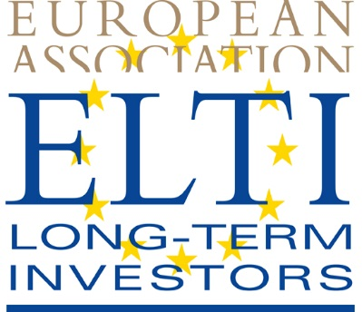

Brussels, 16 December 2014

-Press release-

Establishment of a European Parliament Intergroup on long-term investment and reindustrialisation
The European Association of Long-Term Investors (ELTI) welcomes the European Parliament establishment of an Intergroup on long-term investment (LTI) and reindustrialisation.
The Parliament decision to set up this dialogue structure is a further milestone in recognizing the topic of long-term investment as a top priority on the EU agenda. It will facilitate exchanges between the Members of the European Parliament and long term investors and deepen the understanding for some of the most pressing issues for the EU’s competitiveness, sustainable growth and employment.
This discussion group should encourage reflection and be an essential forum for a continuous review of the prevailing prospects for LTI. The ELTI association hopes that the intergroup will allow to address all issues relevant to LTI including accounting, statistics and prudential treatment of long-term investment, focusing on the relevant priority sectors: industry, infrastructure, innovation, energy efficiency, SMEs.
Alongside the MEPs who actively campaigned for its establishment, ELTI members, federations, professional organisations, trade unions and think tanks did join forces in favour of this initiative. Members of the ELTI Association are ready to support the intergroup’s work and actively participate in a cross-cutting dialogue on LTI to strengthen financing of the real economy.
Contact:
Secretary-General D. de Crayencour
decrayencour@eltia.eu
http://www.eltia.eu/

***

About ELTI: Launched after the publication of the European Commission Green Paper on the Long-Term financing of the European Economy, in July 2013, the Association gathers 22 European long-term financial institutions. With a combined balance sheet of € 2.3 trillion, ELTI’s goal is to promote long-term investment in close alignment with the objectives and initiatives developed by the European Union to foster sustainable, smart and inclusive growth and job creation.

List of ELTI members (assets in brackets):

Full Members
- Belgium: The Federal Holding and Investment Company “SFPI” (€ 0.775 bn)
- Bulgaria: Bulgarian Development Bank “BDB” (€ 0.850 bn)
- Croatia: Croatian bank for reconstruction and Development “HBOR” (€ 3.4 bn)
- Czech Republic: Ceskomoravska zarucni a rozvojova banka “CMZRB” (€ 4.4 bn)
- France: Caisse des Dépôts “CDC” (€ 287 bn)
- France : BPI France (€ 19 bn)
- Germany: KfW (€ 465 bn)
- Greece: National Bank of Greece “NBG” (€ 140 bn)
- Hungary: MFB Hungarian Development Bank “MFB” (€ 4.7 bn)
- Italy: Cassa Depositi e Prestiti “CDP” (€ 305 bn)
- Latvia: The Latvian Development Finance Institution “ALTUM” (€ 0.97 bn)
- Luxembourg: Société Nationale de Crédit et d’Investissement “SNCI” (€ 1.31 bn)
- Malta: Bank of Valletta “BOV” (€ 7 bn)
- Poland: Bank Gospodarstwa Krajowego “BGK” (€ 10.6 bn)
- Portugal: Banco BPI (“BPI)“ (€ 43 bn)
- Slovenia: Slovenska izvozna in razvojna banka “SID” (€ 4.1 bn)
- Spain: Instituto de Crédito Oficial “ICO” (€ 115 bn)

Associate Members
- Nordic Investment Bank “NIB” (€ 0.024 bn)
- Germany: NRWBank (€ 150 bn)
- Greece: Consignment Deposits and Loans Fund “CDLF” (€ 8 bn)
- Netherlands: Algemene Pensioen Group “APG” (€ 240 bn)
- Turkey: Turkije Sinai Kalkinma Bankasi A.S. “TSKB” (€ 4.3 bn)
- European Investment Bank “EIB” (€ 508 bn)
- Council of Europe Development Bank “CEB” (€ 26 bn)

